Presta Shop – Performance Report
31/08/2026

Evozon Software
http://www.evozon.com
Author: Horatiu Encian
Email: horatiu.encian@evozon.com

Contents
Overall Results / Summary 2
Environment details 3
Script and execution notes 3
Concurrent user results 4
Average response time: Static Pages 4
Average response time: Search and search based pages 5
Average response time: 100 concurrent users DATE comparison 6
Server Statistics 7
Page Statistics 9
Labels and Links 9

Overall Results / Summary

- Trend: throughput scales almost linearly to 30 users, then falls while response times explode, retrograde throughput, i.e. a queue collapse, not a graceful capacity ceiling.
- Point of degradation: between 30 and 50 users. Users +67%, throughput −30%, average response time ×6.1, p95 ×5.7.
- Optimal operating point: ~10 req/s / ~24 users (77% of peak, p95 under ~1.5 s). Absolute maximum is 13 req/s / 30 users for short bursts. The 50-user run proves the limit: it delivers the same 9.16 req/s the system serves comfortably at ~22–24 users, for 8× the latency — zero extra capacity, all penalty.
- Error rate is a lagging indicator — do not use it as the SLO. At 100 users the site is functionally dead (p95 = 34.7 s) while still reporting 99.65% success. Errors only appear at 200 users (2.17%, incl. connections refused). Alert on p95 > 2,500 ms, or on throughput falling as users rise.
- Bottleneck is the static-asset fan-out on heavy HTML pages, not the application code. All AJAX/cart endpoints hold flat medians to 200 users (Ajax update cart: 58 ms median at 200 users), while every full-page [GET] collapses. An 11 KB login page slowing ×47 cannot be its own fault — it is queued behind the others.
- Highest-leverage fix: the 1.59 MB homepage. Slowest page even at 1 user (808 ms), highest volume, and 80% of all bandwidth at the knee. Then move static assets to a CDN and enable full-page caching for homepage/category.
Load test remark: the site does not fail, it stalls — safe to ~24 users / 10 req/s, collapses past 30, and the fix is static-asset delivery, starting with a 1.59 MB homepage.

Environment details

Environment:
http://wwwnew.tui.pl/
Web Server Targeted:
http://web2.tui.pl

Script and execution notes

- We have a delay timer between requests of 10 seconds
- Ramp-Up period of 1 thread / 2 seconds (e.g. 10 threads will start in 20 seconds)
- Cache Enabled
  - Start with an empty cache
  - Cache is cleared after each iteration
- Requests are filtered to requests only the resources from the server
(excludes CDN or other sources)

Concurrent user results

Average response time: Static Pages

- Load times are high! (average > 5seconds)
- Home Page and Destination Page are the slowest
- With 300 users we’ve got 19% errors (502 - Bad Gateway)

Average response time: Search and search based pages
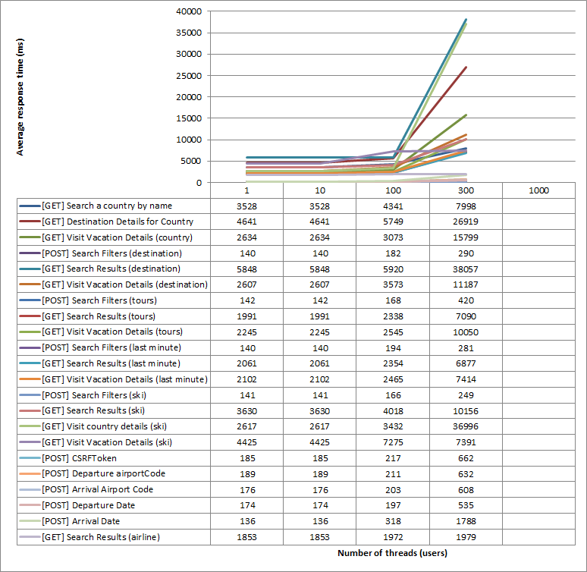
- Load times are high!
- With 300 users we’ve got 19% errors (502 - Bad Gateway)

Average response time: 100 concurrent users DATE comparison

Server Statistics

Run details:
- Date: 12/11/2014
- Start Time: 17:15 pm (server time)
- End Time: 18:05 pm (server time)
- Users: 300
- Environment: web2.tui.pl

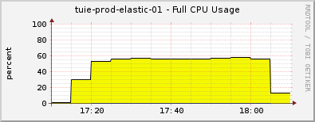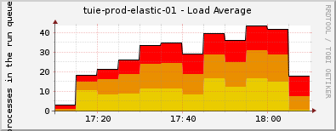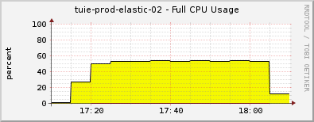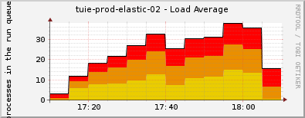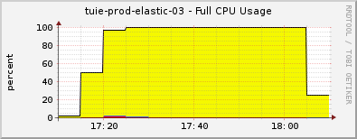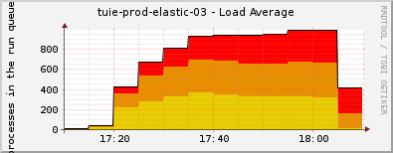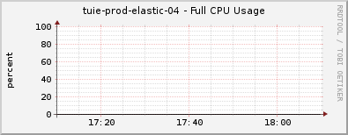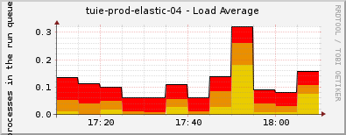

- Elastic search nodes have a big load on the CPU Usage and Load Average
- Tuie-prod-elastic-03 has a higher load than 01 and 02
- Tuie-prod-elastic-04 has no load

Tuie-prod-web-02 statistics:
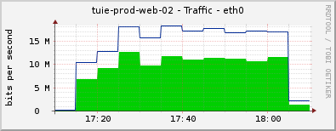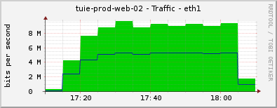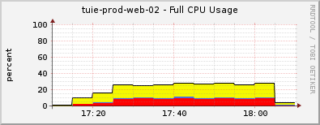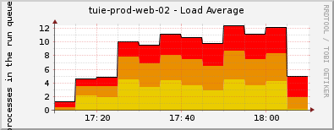

Page Statistics

TBD…

Labels and Links

To be updated …
Label | URL
Home page | wwwnew.tui.pl
Wishlist page | /
Last minute offers | /wishlist
Ski page | /search/lastMinute
Promotion Page | /narty
Tours Page | /promocje
Charters Page | /wycieczki-objazdowe
Destination Page | /bilety-lotnicze
Airline Tickets Page | /wypoczynek
Search a country | /textsearch/?text=${countryName}
Search Results (destination) | /destination-details/${countryCode}
Vacation Details (destination) | /${destLink}
Search Results (tours) | /search/tour?q=${searchFilters}
Vacation Details (tours) | /${destLink}
Search Results (last minute) | /search/lastMinute?q=${searchFilters}
Vacation Details (last minute) | /${destLink}
Vacation Details (ski) | /${resortLink}
Search Results (airline) | /chartersListPage?${searchFilters}

